**Research on** **Power Supply for DC Motor Speed Control**

Christian Gulay Gumapac (Student)

[christian.gumapac@bisu.edu.ph](mailto:christian.gumapac@bisu.edu.ph),

Max Angelo Dapitilla Perin (Instructor)

Faculty of Department of Computer Engineering, College of Engineering, Architecture and Industrial Design, Bohol Island State University-Main Campus, maxangelo.perin@bisu.edu.ph

Imaginative Abstract. Power is the backbone of any electronic system and the power supply is what feeds the system. Choosing the right supply can be the critical difference between a device working at optimum levels and one that may deliver inconsistent results. In addition to alternating current (AC) to direct current (DC) power supplies, DC to DC converters is also available. If DC is already available in your system, a DC-to-DC converter may be the better design. Smaller electronic devices (such as computers) require direct current to operate with an AC-to-DC converter from wall power. Alternating current is used for equipment that have motors (refrigerators are an example). Which type of current to use depends on the load being powered.

Keywords: Alternating Current, Direct Current, Electronic System, Power Supply.

ACM Reference Format:

**Student 1**, Christian Gulay Gumapac. 2022. **Title**. In Research Project Presentation for Bachelor of Science in Electrical Engineering 3 in CPE 03 – Microprocessor Systems S.Y. 2021-2022, 2nd Semester, Bohol Island State University-Main Campus, Tagbilaran City, Republic of the Philippines. ACM, New York, NY, USA

1. Introduction

DC motor has been widely used in various fields among which single-phase, two-phase, three equally endless variety of operating mode, and each class of brushless DC motor drive system is divided into multiple, rather half-bridge drivers and full bridge drivers become the most widely used drive. Full-bridge driving mode can be divided into a variety of the most commonly used is the star and angled connector, select the drive mode will directly affect the performance and cost of the motor, so select the appropriate drive way is a top priority.

Power supply Motor speed control of DC motor is nothing new. A simplest method to control the rotation speed of a DC motor is to control its driving voltage. The higher the voltage is the higher speed the motor tries to reach. Most of the power supplies are in the form of laptop chargers, cell phone adaptors, computer supplies and lab AC – DC supplies.

**2 CORE COMPONENTS OF A POWER SUPPLY**

2.1The Transformer

The transformer is used to step the AC voltage up and down as well as provide isolation between the electronic system and the AC power. It transfers electrical energy between the primary winding and secondary winding, and it does so without changing the frequency. The transformer’s primary winding connects to the ac voltage source, while the secondary one correlates to the load. The two windings aren’t physically connected, but there is an induced voltage in the secondary winding in accordance with Faraday’s law.

2.2. The Rectifier

The rectifier is responsible for changing AC power to pulsating DC power. The basic rectifier is a diode — that is, a unidirectional device operating as a rectifier in the forward direction. The half-wave, the full-wave bridge type, and the full-wave center-tapped are the three basic rectifier circuits that use diodes.

2.3. The Filter

The filter changes the pulsating DC produced by the rectifier to a smooth DC level. It suppresses ripple, which is the AC component in a signal following rectification. High ripples can damage the load. There are two main types of filters for power supplies: C-filters and RC-filters. C-filters are the simplest version of the two.

2.4. The Regulator Circuits

The voltage regulator helps ensure that the DC output voltage is steady regardless of any variation in the input voltage, which enables the load to operate properly. The most common types of regulators are the series voltage regulator and the shunt voltage regulator.

**3 Classification of Power Supply and Its Different Types**

3.1 The below table tells the basic types of power supplies for following conditions.

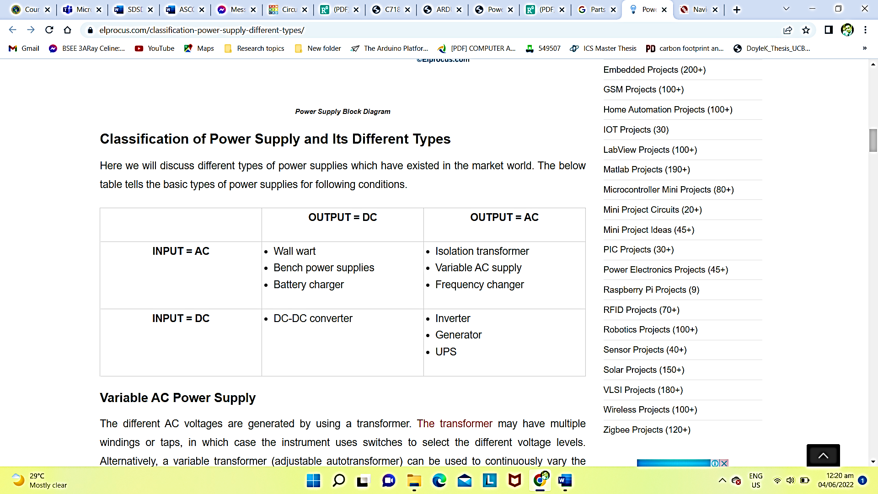

3.2 Different Types of Power Supplies Which Have Existed in The Market World.

Variable AC Power Supply

The different AC voltages are generated by using a transformer. The transformer may have multiple windings or taps, in which case the instrument uses switches to select the different voltage levels. Alternatively, a variable transformer (adjustable autotransformer) can be used to continuously vary the voltages. Some variable AC supplies are included meters to monitor the voltage, current, and/or power.

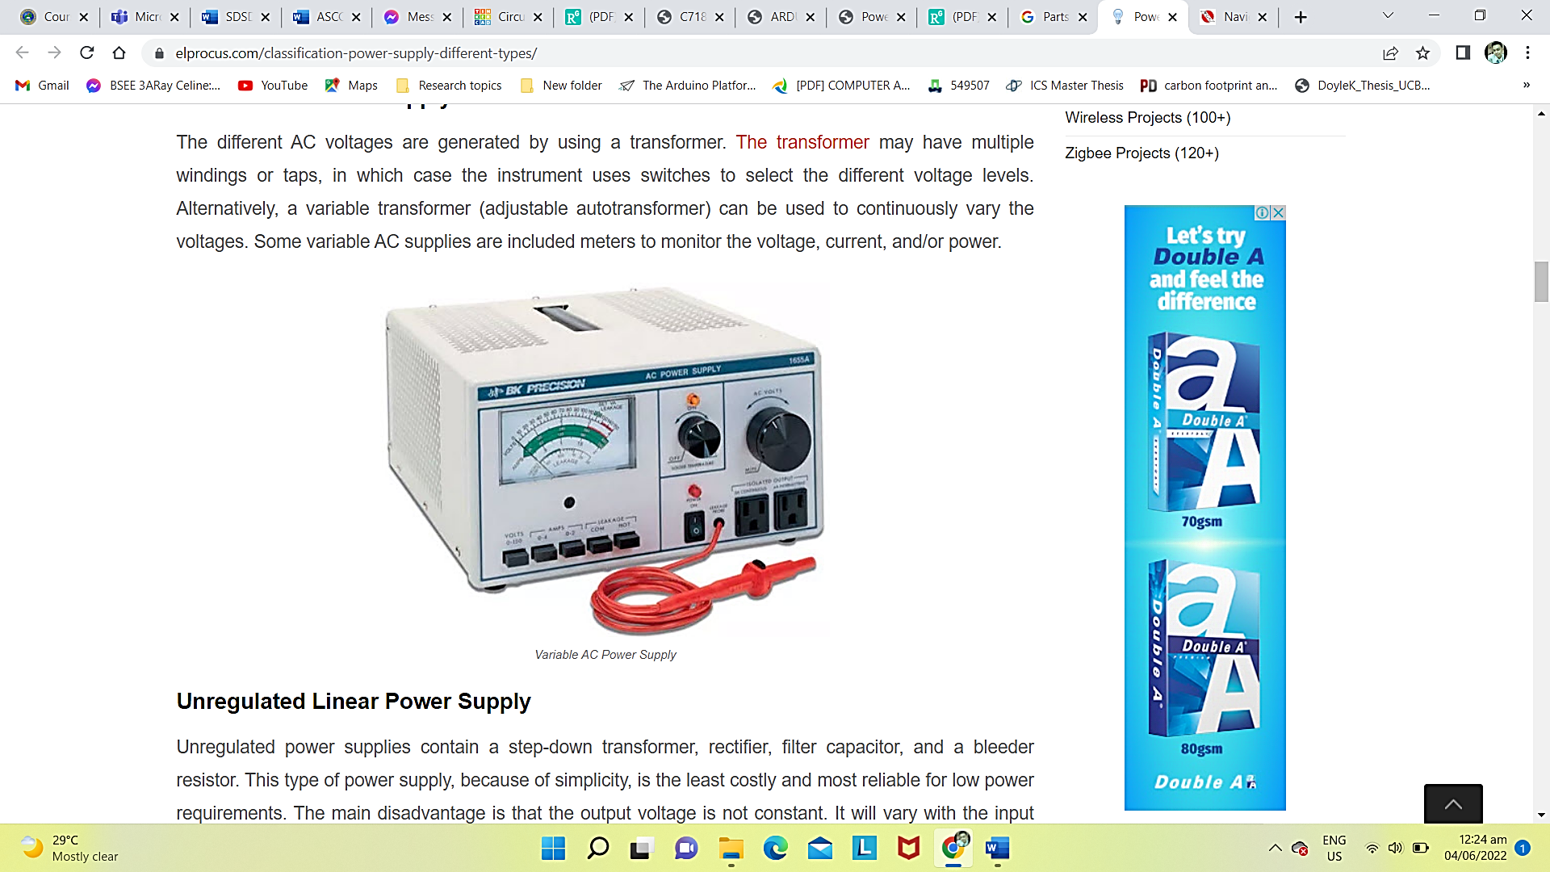

Unregulated Linear Power Supply

Unregulated power supplies contain a step-down transformer, rectifier, filter capacitor, and a bleeder resistor. This type of power supply, because of simplicity, is the least costly and most reliable for low power requirements. The main disadvantage is that the output voltage is not constant. It will vary with the input voltage and the load current, and the ripple is not suitable for electronic applications. The ripple can be reduced by changing the filter capacitor to an LC (inductor-capacitor) filter, but the cost becomes more.

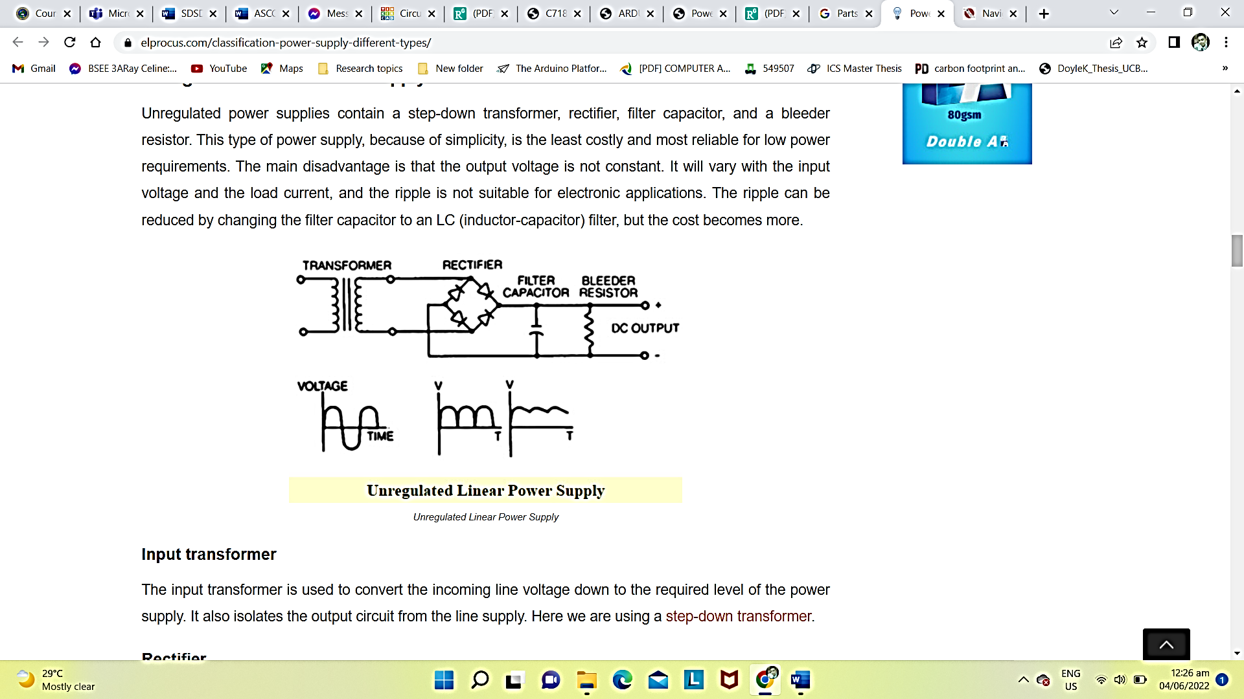

Regulated Linear Power Supply

Regulated linear power supplies are same as the unregulated linear power supply except that a 3-terminal regulator is used in place of the bleeder resistor. The main aim of this supply is to provide the required level of DC power to the load. The DC power supply uses an AC supply as the input. Different applications require different levels of attributes voltages, but nowadays the DC power supplies provide an accurate output voltage. And this voltage is regulated by an electronic circuitry so that it provides a constant output voltage over a wide range of output loads.

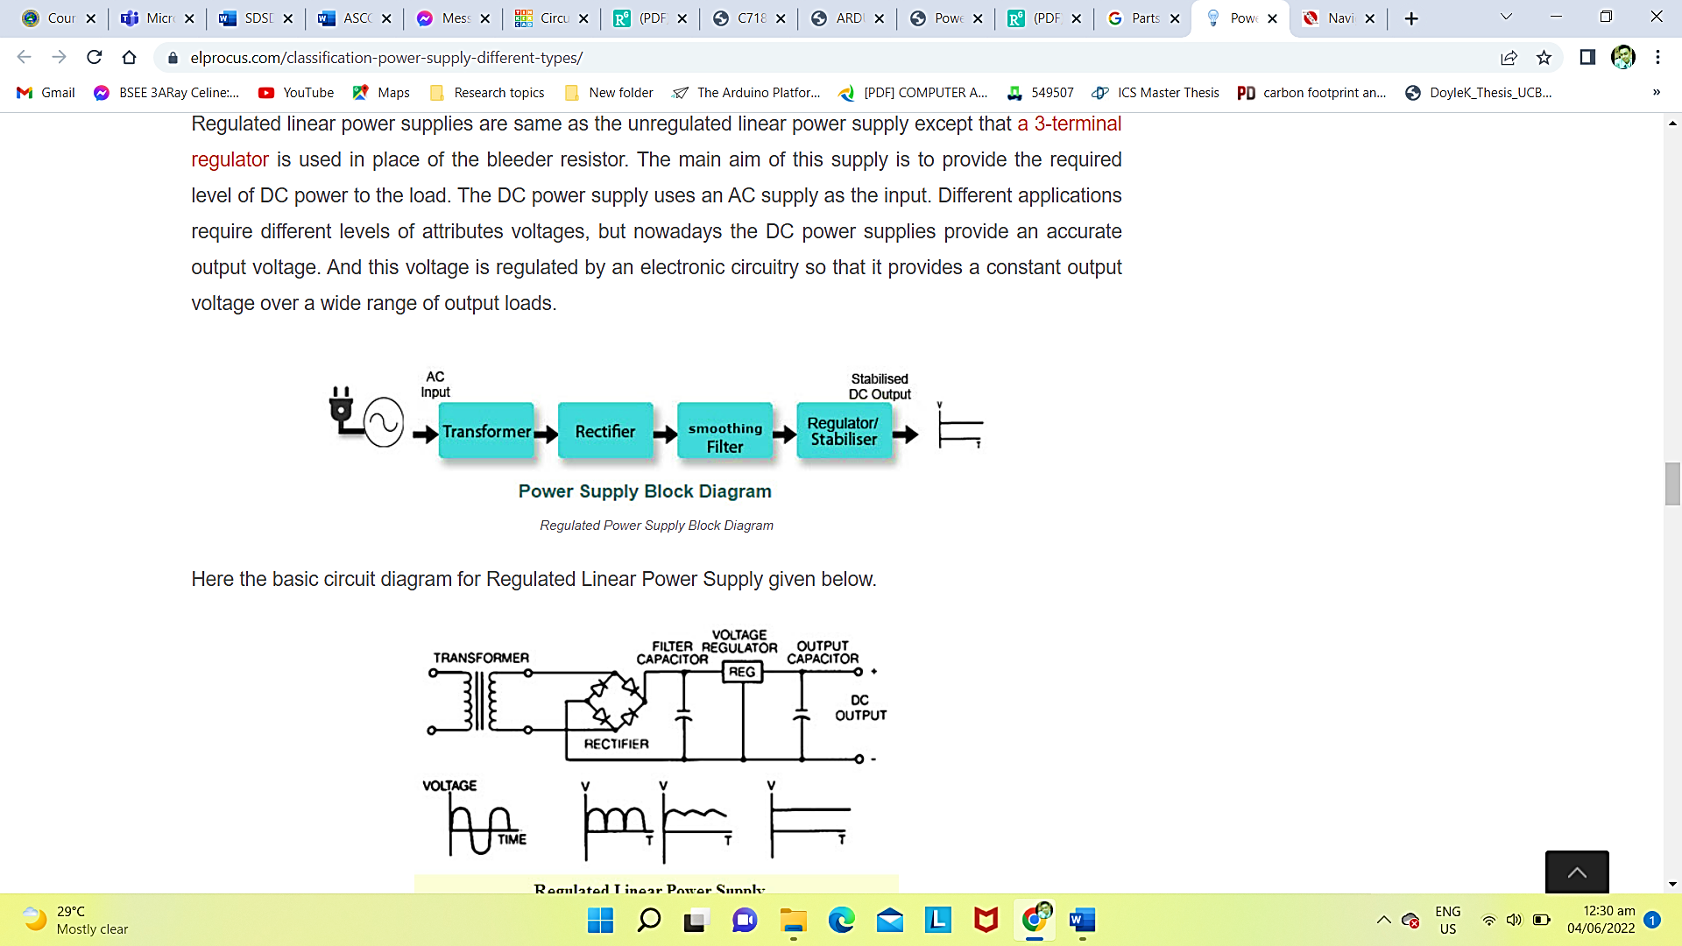

DC Power Supply

A DC power supply is one that provides a consistent DC voltage to its load. Based on its plan, a DC power supply might be controlled from a DC supply or from an AC supply like the power mains.

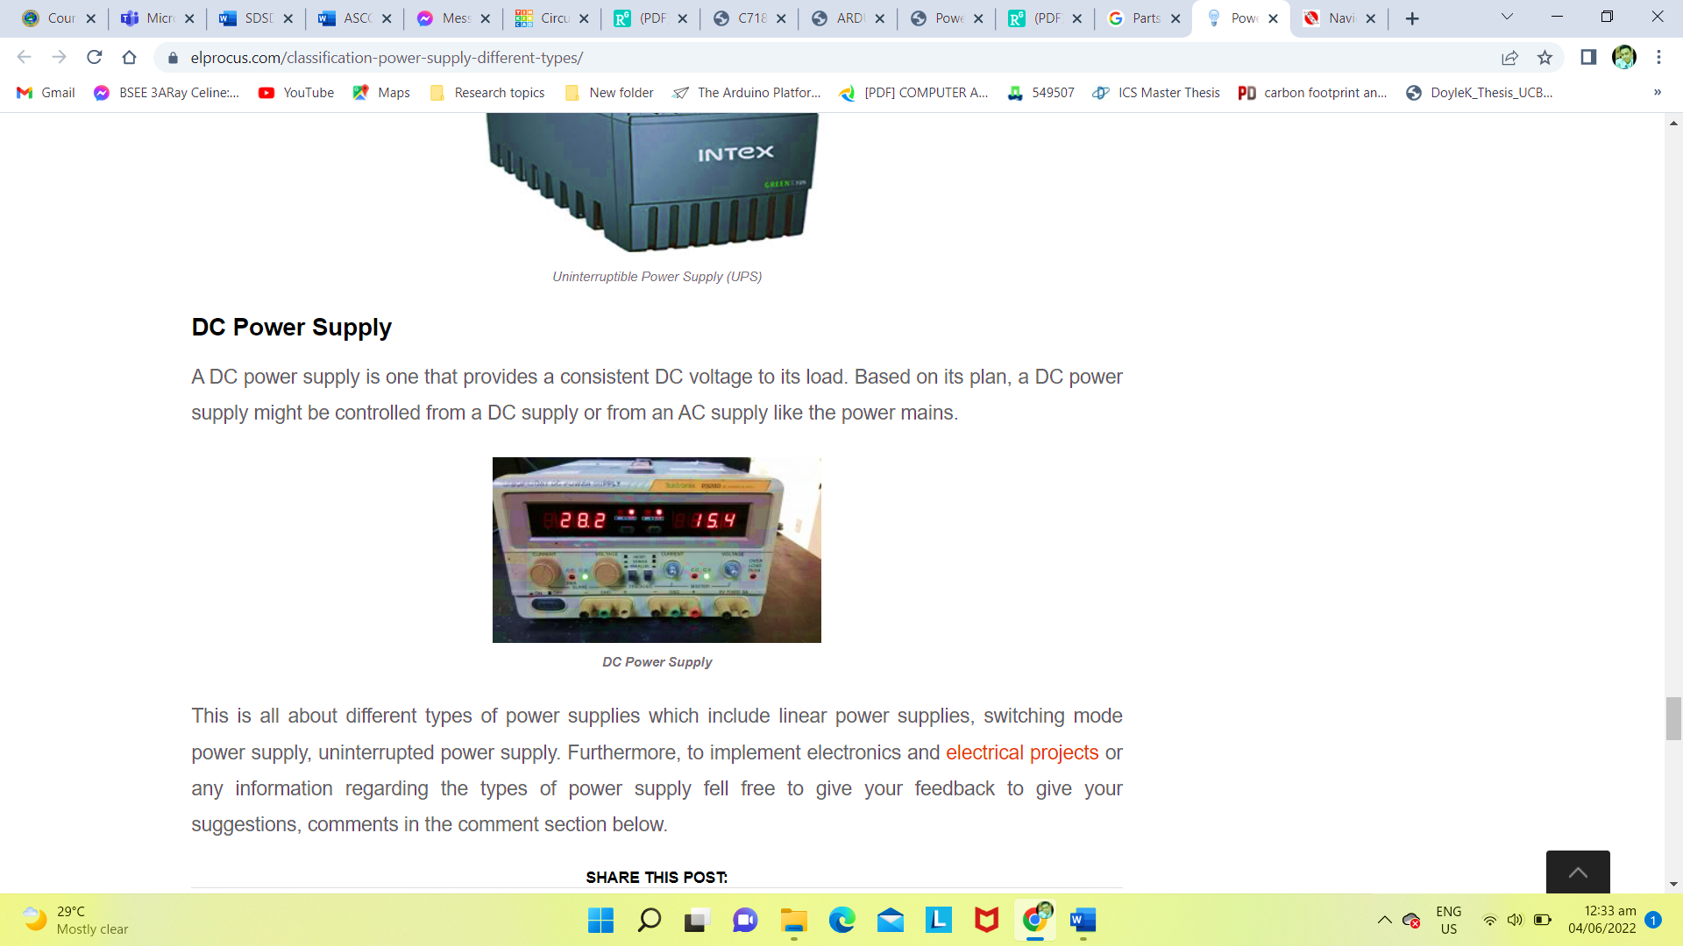

**4 BLOCK DIAGRAM IN A CIRCUIT**

Circuit designing is a technique of designing modern and efficient circuits. It is the thing which make an electrical engineer. It creates a difference between an electrical engineer and an electrician.

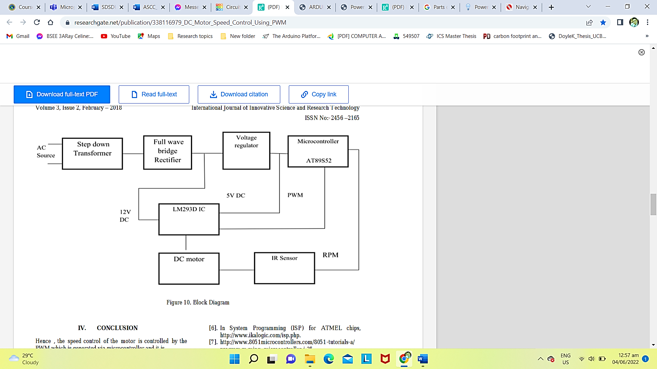

The working is done by first a AC source is given via the power supply and by using the step down transformer the AC source is covert into the DC source and we use full wave bridge rectifier to convert the AC to DC in low voltage so that the motor will run at low voltage and regulator is used to give the whole setup or components the regulated voltage 5V and microcontroller is used to generate the pulse width wave. When applying PWM controlling method, keep in mind that using a motor is as low pass system. PWM method is the high frequency avoided and we know that large motor is mainly inductive so avoid high frequency, hence will not perform well using high frequencies. This method work on low frequency so lower frequency is better than higher frequency. motor driving IC will drive the microcontroller for minimum amount of current and it will switch on and switch off motor at a required speed. IR sensor will count the speed of the motor , which is interference with 555 timer and it will detected by RPM. Microcontroller is used to generate the pulse width and it will show the speed of the motor and it will control the speed by indicating in the LCD display .microcontroller generate pulse width modulation signal it gives to the motor driving IC L293D and it increases the voltage of the source and motor regain their speed at desired. By using the pulse width modulation we can easily find the speed at required load and it is calculated but the speed will be at zero stage to rated speed only. Now a day PWM technique are using in fuzzy logic control system, so PWM method is very efficient and reliable method to control the speed of motor so it future is also bright in the modern era with fuzzy logic.

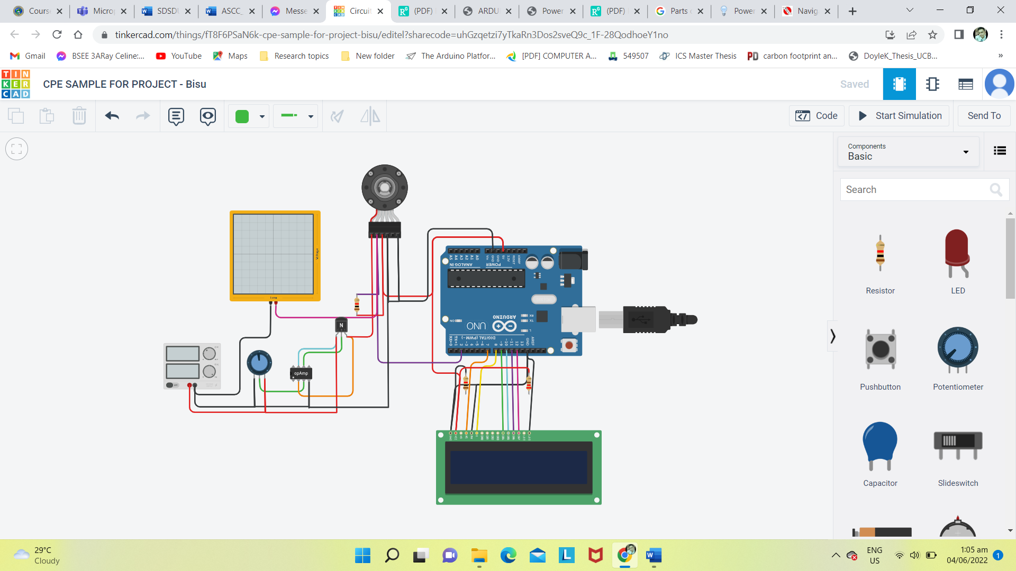**APPENDIX**

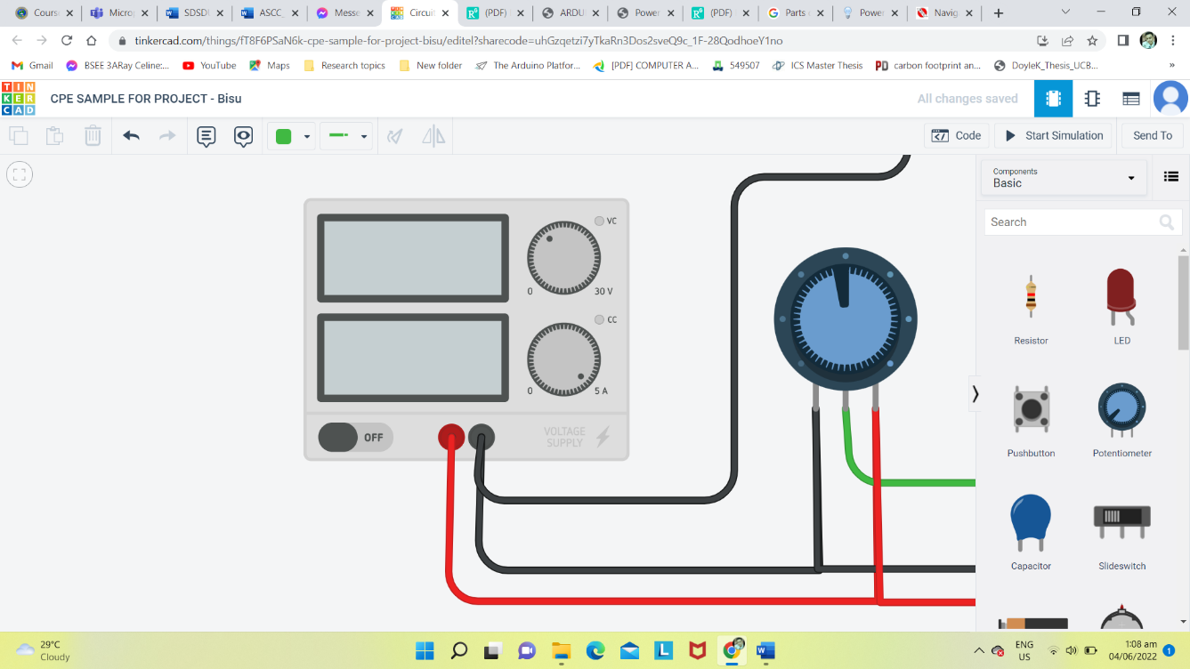**APPLICATION OF POWER SUPPLY FOR DC MOTOR SPEED CONTROL**

**REFERENCES**

POWER SUPPLY

[1]. http://www.ijert.org/view-pdf/1641/speed-control-of-dc-motor-using-analog-pwm-technique <http://www.ijera.com/papers/Vol3_issue1/DP31778783.pdf>

[2]. http://itech.fgcu.edu/faculty/zalewski/CDA4170/files/Presentation Tim.pdf

[3]. Pulse width modulator module (PWMM), ATmega8L data sheet.

[4]. Peter Spasov, “Microcontroller Technology: The 68HC11”

[5]. Prentice Hall, 5th edition, 2004.

[6]. In System Programming (ISP) for ATMEL chips, <http://www.ikalogic.com/isp.php>.

[7]. http://www.8051microcontrollers.com/8051-tutorials-a/ program m ming -microcontroller-j-25

[8]<file:///C:/Users/christian%20gumapac/Downloads/ARDUINO%20BASED%20DC%20MOTOR%20SPEED%20CONTROL.pdf>

[9] <https://www.researchgate.net/publication/347893879_POWER_SUPPLY>

[10] <https://www.elprocus.com/classification-power-supply-different-types/>

[11] <https://www.actpower.com/educational/power-supply-component-availability/>

[12] https://learnabout-electronics.org/Downloads/Power%20Supplies%20Module%2001.pdf